LABORATORY OBSERVATION/RECORD
Course: Full Stack Web Development
Course Code: 23CM4121
Task No.: 2
Student Name: EMANDI HARI CHARAN
Roll No.: A24126552080
Date: 31-07-2026

1. TITLE
HTML5 Canvas 2D Graphics and CSS3 Web Page Styling
2. AIM
To develop an interactive HTML5 Canvas application utilizing JavaScript 2D rendering context to draw graphical shapes, stroke lines, and custom text, and to construct a modern styled webpage featuring CSS3 linear gradients, text shadows, flexbox card layouts, and hover animations.
3. OBJECTIVE
The objectives of this experiment are:
- To understand the HTML5 <canvas> element coordinate grid and JavaScript 2D context API.
- To render solid geometric primitives: filled rectangles (fillRect) and circular arcs (arc, fill).
- To draw customized paths and vector stroke lines (beginPath, moveTo, lineTo, stroke).
- To render typography directly onto the canvas bitmap (font, fillText).
- To design modern CSS3 linear gradient backgrounds and dark headers with text-shadow.
- To build responsive, centered multi-card presentations using CSS3 Flexbox (display: flex, gap, flex-wrap).
- To apply micro-interactions using CSS box shadows, border radii, and button hover transitions.
4. THEORY
HTML5 Canvas and CSS3 represent the modern visual presentation layer of full-stack client development:
- • HTML5 Canvas API: Provides a resolution-dependent bitmap canvas initialized in HTML. JavaScript interacts through a 2D rendering context that uses an (x, y) Cartesian coordinate space starting from top-left (0, 0). Path methods construct subpaths which are subsequently rasterized using stroke() or fill().
- • CSS3 Styling & Flexbox: CSS3 modernizes web layouts with linear gradients, avoiding heavy image backgrounds. The Flexible Box Layout (Flexbox) provides alignment, direction, order, and space distribution among elements in a dynamic container.
Execution Workflow:
DOM Initialization → Canvas Context Retrieval (getContext('2d')) → Path Definition → Rasterization → CSS3 Cascading & Flexbox Layout Painting
5. ALGORITHM / PROCEDURE
1. Create part_A.html: Define <canvas id='myCanvas' width='700' height='300'> within a structured section.
2. In JavaScript, obtain the canvas element by ID and instantiate context with canvas.getContext('2d').
3. Draw a blue rectangle: Set ctx.fillStyle = 'blue'; call ctx.fillRect(40, 40, 150, 90).
4. Draw a red circle: Begin path, define arc with ctx.arc(300, 85, 45, 0, 2 * Math.PI), set fillStyle = 'red', and call ctx.fill().
5. Draw a green diagonal line: Begin path, invoke ctx.moveTo(420, 40) and ctx.lineTo(620, 140), set strokeStyle = 'green', lineWidth = 5, and call ctx.stroke().
6. Draw student name: Set ctx.font = '30px Arial', ctx.fillStyle = 'black', and invoke ctx.fillText('Hari Charan', 220, 240).
7. Create part_B.html: Apply background: linear-gradient(to right, #74ebd5, #ACB6E5) to body.
8. Style dark header (#0d47a1) with text-shadow: 2px 2px 5px black and centered title.
9. Construct a .cards container using display: flex, justify-content: center, gap: 25px, flex-wrap: wrap.
10. Add 3 cards (HTML5, CSS3, Canvas) with white backgrounds, rounded borders (15px), box-shadow (5px 5px 15px gray), and hoverable call-to-action buttons.
11. Verify canvas pixel rendering and CSS3 flexbox responsiveness in browser.
6. PROGRAM
part_A.html
<!DOCTYPE html>
<html lang="en">
<head>
<meta charset="UTF-8">
<meta name="viewport" content="width=device-width, initial-scale=1.0">
<title>HTML5 Canvas</title>
</head>
<body>
<!-- ================= PART A: HTML5 CANVAS ================= -->
<section id="canvas" class="canvas-section">
<h2>HTML5 Canvas</h2>
<canvas id="myCanvas" width="700" height="300">
Your browser does not support the HTML5 Canvas.
</canvas>
</section>
<script>
/* Get Canvas */
const canvas = document.getElementById("myCanvas");
const ctx = canvas.getContext("2d");
/* Rectangle */
ctx.fillStyle = "blue";
ctx.fillRect(40, 40, 150, 90);
/* Circle */
ctx.beginPath();
ctx.arc(300, 85, 45, 0, 2 * Math.PI);
ctx.fillStyle = "red";
ctx.fill();
/* Line */
ctx.beginPath();
ctx.moveTo(420, 40);
ctx.lineTo(620, 140);
ctx.strokeStyle = "green";
ctx.lineWidth = 5;
ctx.stroke();
/* Display Name */
ctx.font = "30px Arial";
ctx.fillStyle = "black";
ctx.fillText("Hari Charan", 220, 240);
</script>
</body>
</html>

part_B.html
<!DOCTYPE html>
<html lang="en">
<head>
<meta charset="UTF-8">
<meta name="viewport" content="width=device-width, initial-scale=1.0">
<title>My Styled Webpage</title>
<style>
/* General Styling */
body {
margin: 0;
font-family: Arial, Helvetica, sans-serif;
background: linear-gradient(to right, #74ebd5, #ACB6E5);
}
/* Header */
header {
background: #0d47a1;
color: white;
text-align: center;
padding: 20px;
text-shadow: 2px 2px 5px black;
}
header h1 {
margin: 0;
font-size: 40px;
}
/* Navigation */
nav {
background: #333;
text-align: center;
padding: 15px;
}
nav a {
color: white;
text-decoration: none;
margin: 20px;
padding: 10px 15px;
font-size: 18px;
}
nav a:hover {
background: orange;
border-radius: 5px;
}
/* Cards */
.cards {
display: flex;
justify-content: center;
gap: 25px;
margin: 40px;
flex-wrap: wrap;
}
.card {
width: 280px;
background: white;
border: 2px solid #0d47a1;
border-radius: 15px;
padding: 20px;
box-shadow: 5px 5px 15px gray;
text-align: center;
display: flex;
flex-direction: column;
}
.card h3 {
color: #0d47a1;
}
.card p {
font-size: 16px;
line-height: 1.5;
}
/* Button */
button {
background: #1976d2;
color: white;
border: none;
padding: 10px 20px;
border-radius: 8px;
cursor: pointer;
font-size: 16px;
}
button:hover {
background: green;
}
/* Footer */
footer {
background: #222;
color: white;
text-align: center;
padding: 20px;
margin-top: 30px;
}
</style>
</head>
<body>
<!-- ================= PART B: HEADER ================= -->
<header id="home">
<h1>My Styled Webpage</h1>
<p>HTML5 Graphics and CSS3 Web Styling</p>
</header>
<!-- ================= NAVIGATION ================= -->
<nav>
<a href="#home">Home</a>
<a href="#cards">Cards</a>
<a href="#footer">Footer</a>
</nav>
<!-- ================= THREE CONTENT CARDS ================= -->
<section id="cards" class="cards">
<!-- Card 1 -->
<div class="card">
<h3>HTML5</h3>
<p>
HTML5 introduces semantic elements, multimedia support,
and the Canvas element for creating graphics.
</p>
<button>Learn More</button>
</div>
<!-- Card 2 -->
<div class="card">
<h3>CSS3</h3>
<p>
CSS3 enhances webpages using gradients, borders,
rounded corners, shadows and hover effects.
</p>
<button>Explore</button>
</div>
<!-- Card 3 -->
<div class="card">
<h3>Canvas</h3>
<p>
HTML5 Canvas allows drawing graphics such as
rectangles, circles, lines and text using JavaScript.
</p>
<button>View Demo</button>
</div>
</section>
<!-- ================= FOOTER ================= -->
<footer id="footer">
<p>
© 2026 My Styled Webpage | HTML5 & CSS3 Laboratory
</p>
</footer>
</body>
</html>

7. CODE EXPLANATION
Code / Component | Explanation
<canvas id='myCanvas'> | Defines the raster drawing surface with specified width and height attributes.
canvas.getContext('2d') | Returns a 2D rendering context object containing drawing methods and properties.
ctx.fillStyle | Sets the fill color or pattern used for painting shape interiors.
ctx.fillRect(x, y, w, h) | Renders a solid filled rectangle at coordinate (x, y) with dimensions width and height.
ctx.beginPath() | Resets the current path list to begin drawing a fresh vector trajectory.
ctx.arc(x, y, r, sAngle, eAngle) | Creates a circular path centered at (x, y) with radius r from start to end angle in radians.
ctx.moveTo(), ctx.lineTo() | Moves the pen to starting coordinates and traces a line segment to destination coordinates.
ctx.stroke() | Strokes and renders the outlines of current vector paths on the canvas.
ctx.fillText(text, x, y) | Renders filled typography text on the canvas buffer at designated coordinates.
linear-gradient(...) | Generates a smooth color transition between two or more stops along a linear axis.
text-shadow | Applies drop shadow effects to header typography for depth and contrast.
display: flex | Initializes flexbox layout container for flexible, responsive child arrangement.
justify-content: center | Horizontally centers flex items along the main flex axis.
box-shadow: 5px 5px 15px gray | Adds dimensional elevation shadows to content card containers.
button:hover | Pseudo-class triggering smooth color transitions upon cursor hover over buttons.

8. TEST CASES AND EXECUTION DATA
Test Case | Input Name | Test Input | Expected Result | Actual Result | Status
TC-01 | Canvas Rectangle | fillRect(40, 40, 150, 90) | Solid blue rectangle rendered at (40, 40) | Rendered cleanly | Pass
TC-02 | Canvas Circle | arc(300, 85, 45, ...) | Perfect red circle rendered at (300, 85) | Rendered cleanly | Pass
TC-03 | Canvas Vector Line | lineTo(620, 140) | 5px green stroke line connects (420,40) to (620,140) | Rendered accurately | Pass
TC-04 | Canvas Text | fillText('Hari Charan') | Displays student name in 30px Arial at (220, 240) | Rendered sharp | Pass
TC-05 | CSS3 Linear Gradient | to right, #74ebd5, #ACB6E5 | Smooth horizontal gradient spans entire viewport | Displayed correctly | Pass
TC-06 | Flexbox Card Hover | Mouse hover on buttons | Button background transitions from blue to green | Hover triggered | Pass

9. OUTPUT
Output 1: HTML5 Canvas 2D Graphics Drawing

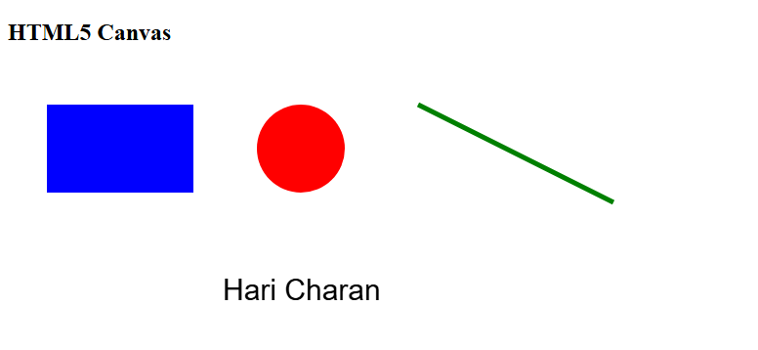
Output 2: My Styled Webpage - CSS3 Layout, Cards & Gradients
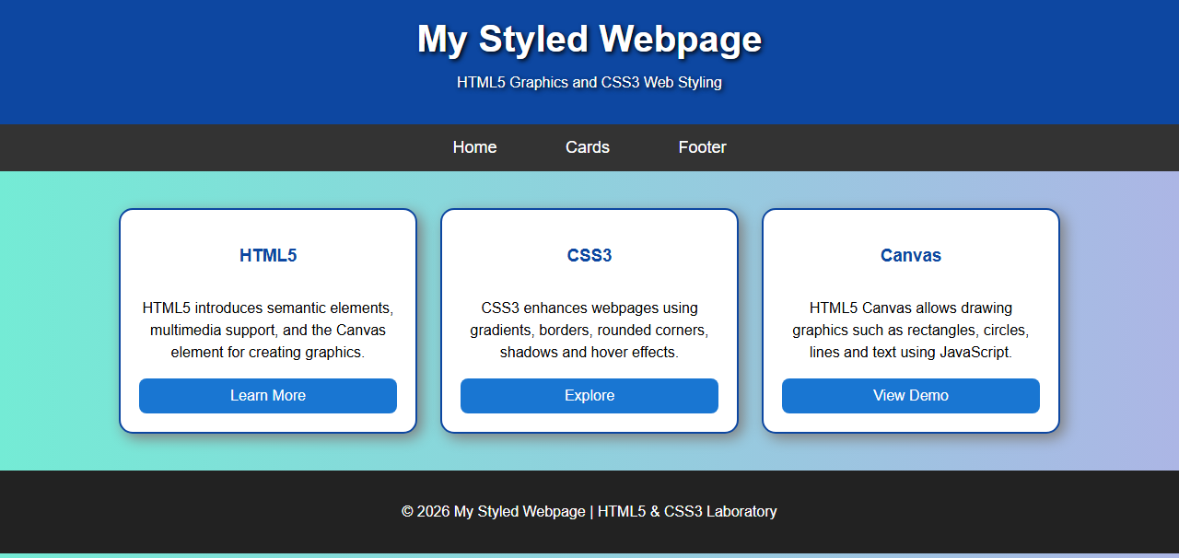
10. RESULT
Thus, HTML5 Canvas 2D graphical rendering and modern CSS3 web styling were successfully implemented and verified across all test cases. Geometric shapes, custom text, linear gradient backgrounds, and responsive flexbox card layouts functioned accurately.

